# Exercise 1(B) - Additional Task 2

For this exercise, the developed mathematical model was not a reasonably accurate representation of the system (electromechanical system of a servo motor) as can be seen from the figure below. All the significant system parameters were not really considered while modelling the dynamics of the given electromechanical system. Only the system gain *K* and time constant $τ$ were considered while modelling the system. Moreover, the order of the system was considered to be one.

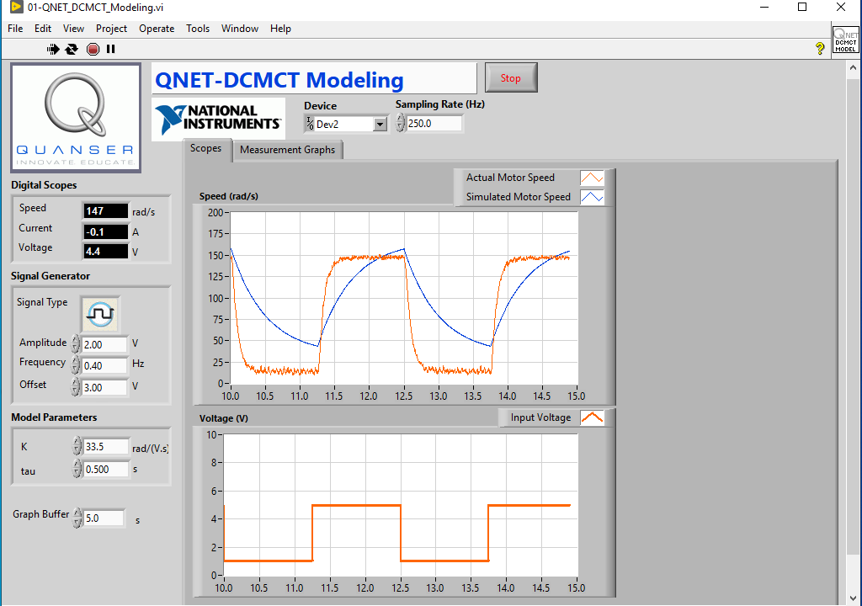

In general, model accuracy is required when system dynamics are really important to achieve accurate control. However, increasing the model accuracy also increases the order of the system (due to non-linear behaviour) which thereby increases the time complexity of simulation and limits real-time computation and control actions. Therefore, most of the systems are modelled with some level of approximation to ease the modelling task as well as to reduce time complexity of real-time computation.